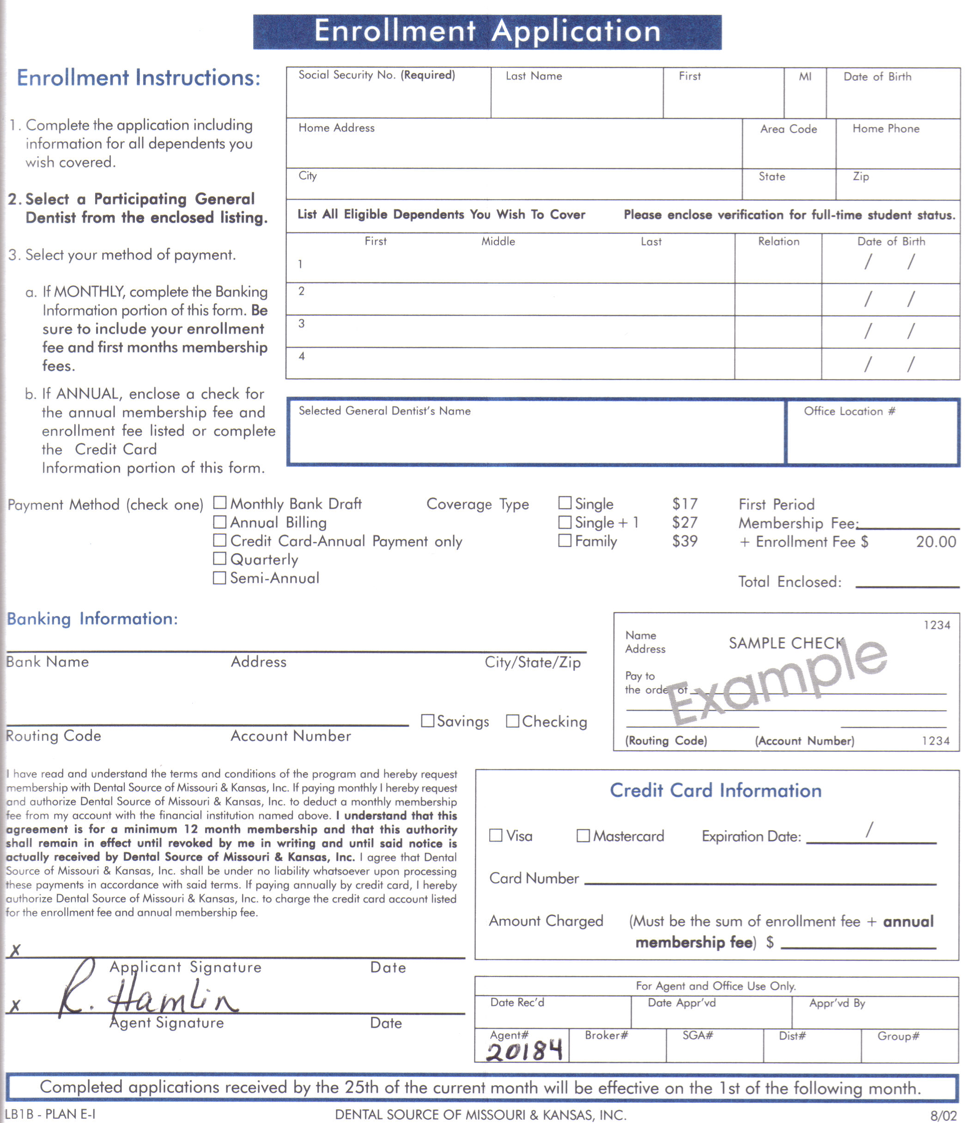

Print this enrollment form with your browsers print command.
After completing the form mail along with your first premium payment to:

Group Benefits, Inc.  21 Nob Hill Drive, Lower Level  St. Louis, MO 63138  Telephone: 314-438-0222 | or | Dental Source  9091 State Line - Suite 101  Kansas City, MO 64114  Telephone: (816) 523-8900

If you have any questions please call.
All checks should be made payable to DENTAL SOURCE.

